Name : Herlan Wijaya
Position : Test Engineer

Basic Programming
1. What is the data-type usually used in arithmetic operation?
Data-type : Float
2. What is the data-type usually used in word and character?
Data-type : String/Varchar
3. What is the output of code below
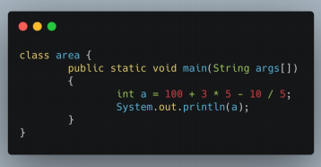
Output : 113

4. What is the output of code below
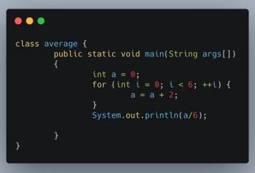
Output : 2

5. What is the output of code below
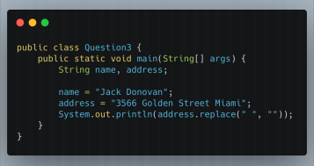

Output : 3566GoldenStreetMiami

Flaky Test
1. What is a flaky test?
Flaky test is a condition where the test that has been run changes over time or after being tested repeatedly, many factors that affect the occurrence of "flaky", for example because of the effect of time, often occurs when we have tested with the status "passed", sometimes when we retest the id time takes slower 1-2 seconds, and instantly the test that we run becomes "failed".

2. An element in a website is using ajax/javascript to show the data (processed as asynchronous). What do you do to test that element?

How to test when a website uses ajax/javascript to display data, there are several ways first, test with manual testing, or if using automatic test, using "wait", "implicit" , Explicit" , or "WebDriverWait”.

3. A website page can only be accessed with CAPTCHA. How do you test that page?

Almost the same as question no. 2, I have the option to test manually, ask hide "CAPTCHA" to the developer, if the captcha is in the form of numbers or characters, I will add a form to the test script for CAPTCHA input so that the test script can be continued.

